

**TV Online Shop PROJECT**

**Software Requirement Specification**

**Group 1**

# Table of Contents

I. Overview 2

1. Introduction 2

2. System Functions 3

a. Screen Flow 3

b. Screen Details 5

c. User Authorization 6

d. Non-Screen Functions 6

3. Entity relationship diagram 7

Entity description 7

II. Functional Requirements 8

1.Sign in and Sign up8

a. Login 8

b. Sign up 8

2. Home 9

3. TV Detail 10

4. User profile10

5. Change Pass word 11

# I. Overview

## 1. Introduction

Television Online Shop - SWP391's online TV sales system. Tn this system, users will easily find and buy televisions more easily. As for store owners, they will easily manage, sell TV and view sales statistics more easily.

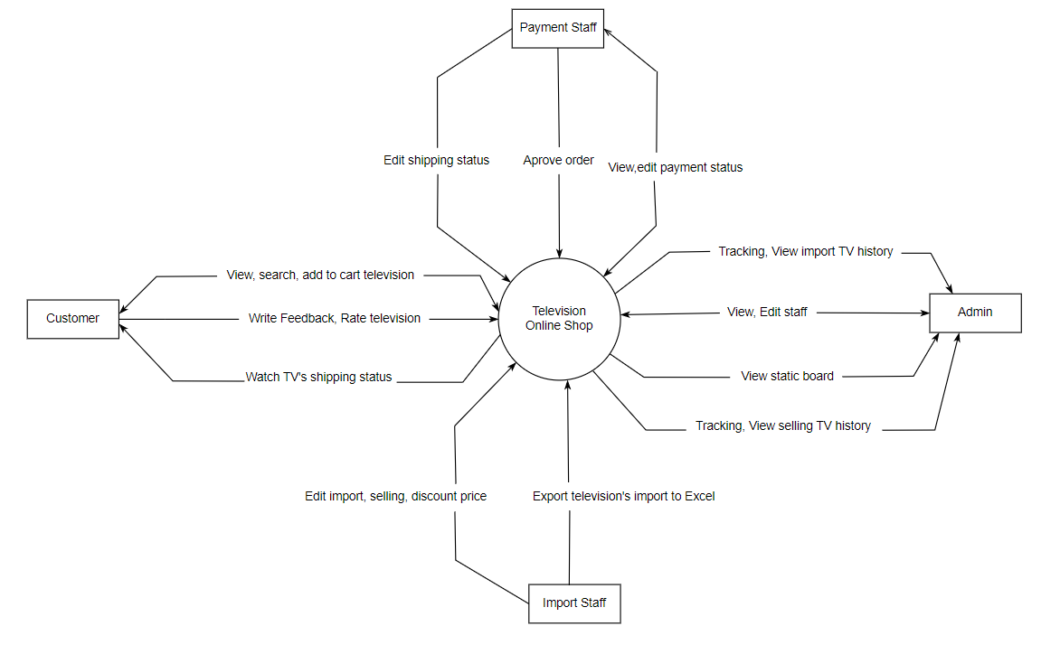

## 2. System Functions

#### a. Screen Flow

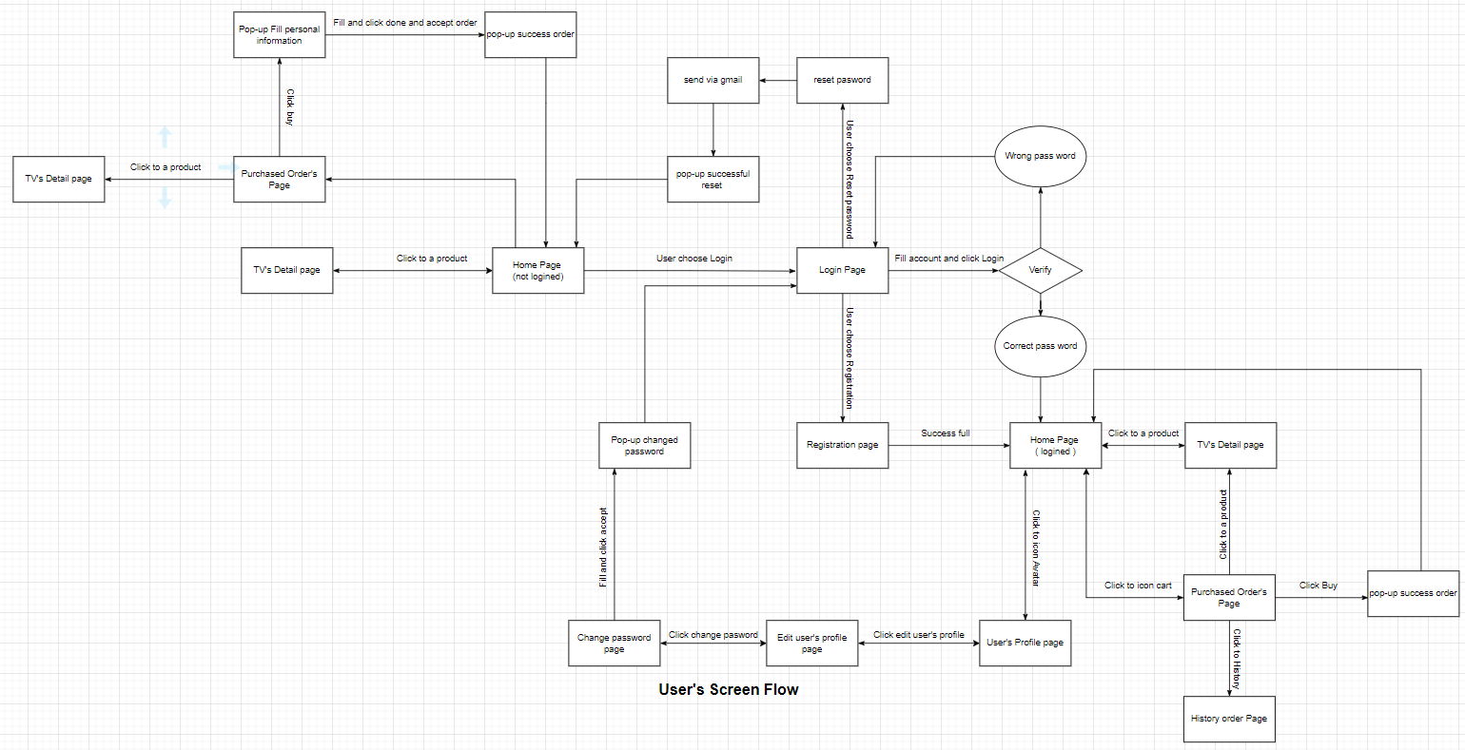

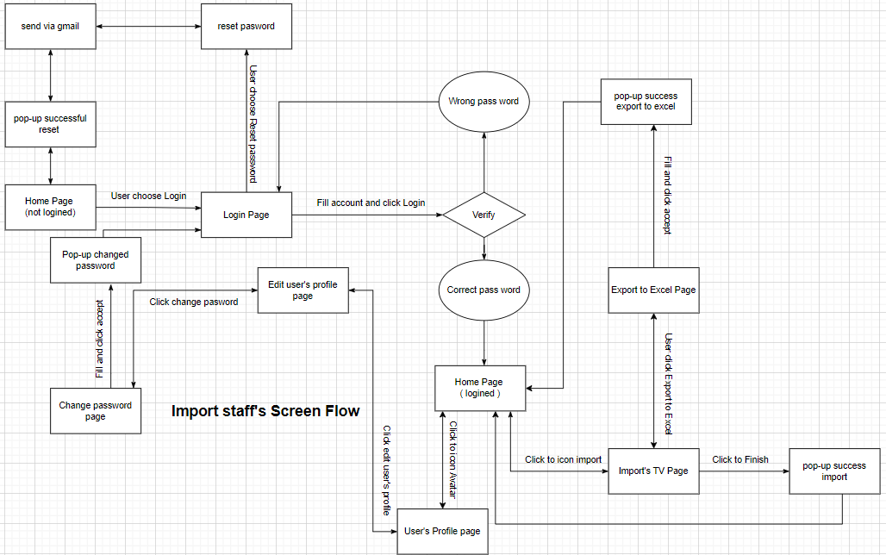

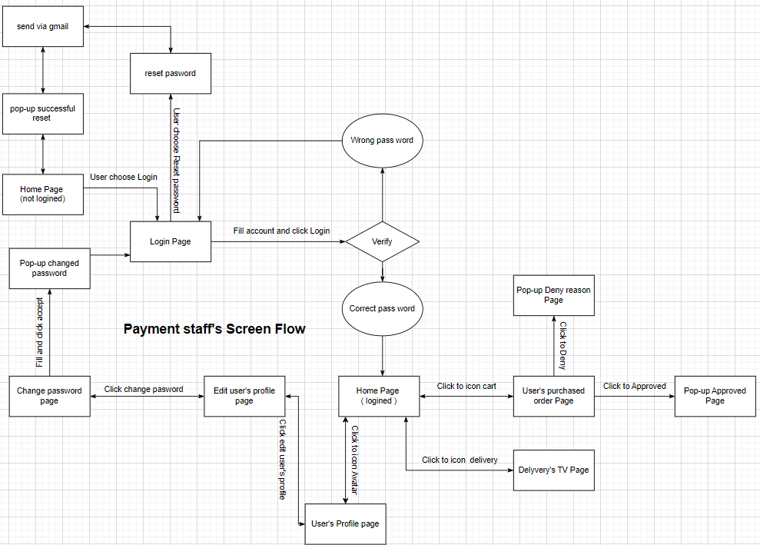

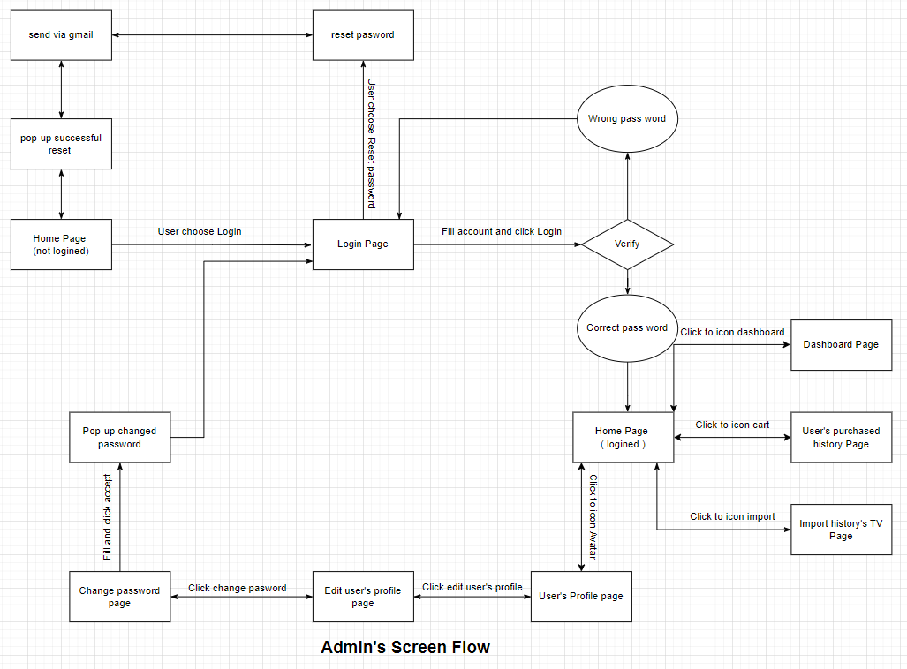

#### b. Screen Details

|  |  |  |  |
| --- | --- | --- | --- |
| **No** | **Feature** | **Screen** | **Description** |
| 1 | Common | Home Page | View, Search TV by type, price, etc. |
| 2 | Common | Login | User enter username, password and able to reset password. |
| 3 | Common | Register | User register account. |
| 4 | Admin | Dashboard | View weekly, monthly, quarterly, yearly statistics. |
| 5 | Admin | User's purchased history Page | View user’s purchased history list. |
| 6 | Admin | Import history’s Page | View import’s history list. |
| 7 | Payment staff | User’s purchased order Page | View, change status (deny, approved). |
| 8 | Payment staff | Delivery’s TV Page | View and change status delivery (pending, shipping, success ). |
| 9 | Import staff | Import’s TV Page | View, change status import’s TV list (Finish, not finish). |
| 10 | Import staff | Export to Excel Page | Export import list to Excel. |
| 11 | Common | Reset Password | Get account when forgetting the password. |
| 12 | Common | User profile | Information of user. |
| 13 | Common | Change password | Change password. |
| 14 | Common | Purchased Order’s Page | View, Edit, Buy list of chose TV. |
| 15 | Common | TV’s Detail Page | View detail of a TV and add to cart. |
| 16 | User | History Order Page | View lost of bought TV. |
| 17 | Common | Edit profile | View, edit personal profile. |

#### c. User Authorization

|  |  |  |  |  |
| --- | --- | --- | --- | --- |
| **Screen** | **Admin** | **User** | **Import staff** | **Payment staff** |
| Dashboard | x |  |  |  |
| Login |  |  |  |  |
| * Login | X | X | X | X |
| * Reset Password | X | X | X | X |
| * Register |  | X |  |  |
| User's purchased history Page | X |  |  |  |
| Import history’s Page | X |  |  |  |
| Delivery’s TV Page |  |  |  | X |
| User’s purchased order Page |  |  |  | X |
| Import’s TV Page |  |  | X |  |
| Export to Excel Page |  |  | X |  |
| User profile | X | X | X | X |
| Subject Setting Detail | X | X |  |  |
| Change password | X | X | X | X |
| Purchased Order’s Page | X | X | X | X |
| TV’s Detail Page | X | X | X | X |
| History Order Page |  | X |  |  |
| Edit profile | X | X | X | X |

In which:

* Role1: Admin who can view statistic and manage staff, user. Manage of TV shop.
* Role2: User who can able login, View TV products and order TV.
* Role3: Import staff who can control importing TV and can be export list of import TV to excel.
* Role4: Payment staff who can confirm order update shipping status, edit payment status.

#### d. Non-Screen Functions

|  |  |  |  |
| --- | --- | --- | --- |
| **Id** | **Feature** | **System Function** | **Description** |
| 1 | Change password | Update password of account | When users forget their password, they can change it. |
| 2 | Security System | Protection Information | The system protects students and teachers information. |
| 3 | Real time system | Be access all times | The system must be alway access all times |

## 

## Entity Relationship Diagram

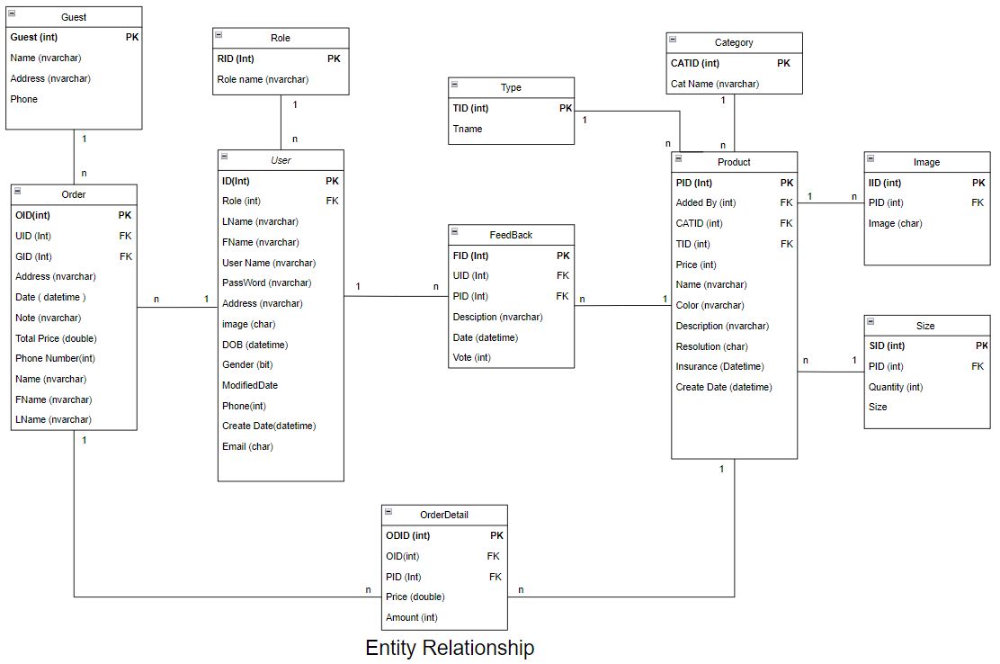

**Entities Description**

|  |  |  |
| --- | --- | --- |
| **#** | **Entity** | **Description** |
| 1 | Product | Store product information. |
| 2 | Image | Store image of product. |
| 3 | Size | Store size and quantity of product. |
| 4 | Type | Store type of product. |
| 5 | Category | Store category of product. |
| 6 | User | Store user information. |
| 7 | Role | Store role of user. |
| 8 | Order | Store order of user and guest. |
| 9 | OrderDetail | Store detail price of single product in a order . |
| 10 | FeedBack | Store detail a Feedback of user about a product. |
| 11 | Guest | Store guest information. |

# II. Functional Requirements

## 1. Login and Sign up

### a.Login

When the user click to Login/Sign up on upper the right of the website they will direct to the login page. They can have the choice to log in or sign up for a new account. If they login successfully, the system will move them directly to the home page for roles. If login fails, they will have to report for login failure and come back to the login page. While the system takes the data of user insert to login, it will check if the account exists or not.

### b. Sign up

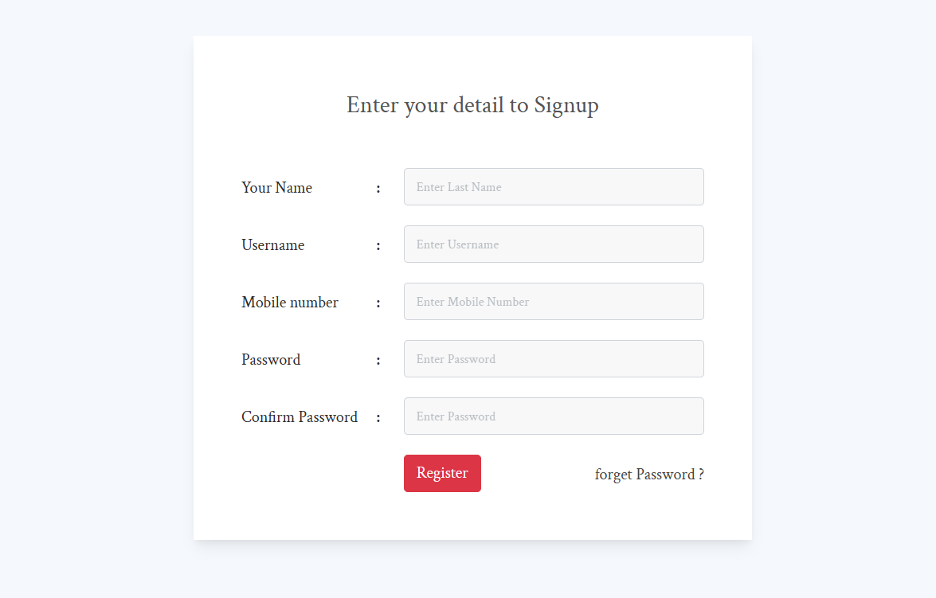

When the user clicks on register on login’s page or register on other ‘s page they will direct to the register page. Page will request to fill the form such that when click on submit button. If all the input text formats the conditions. Page will accept users to create the new account. The data will be added to the database and the page will auto login and respond to the Home page.

## Home

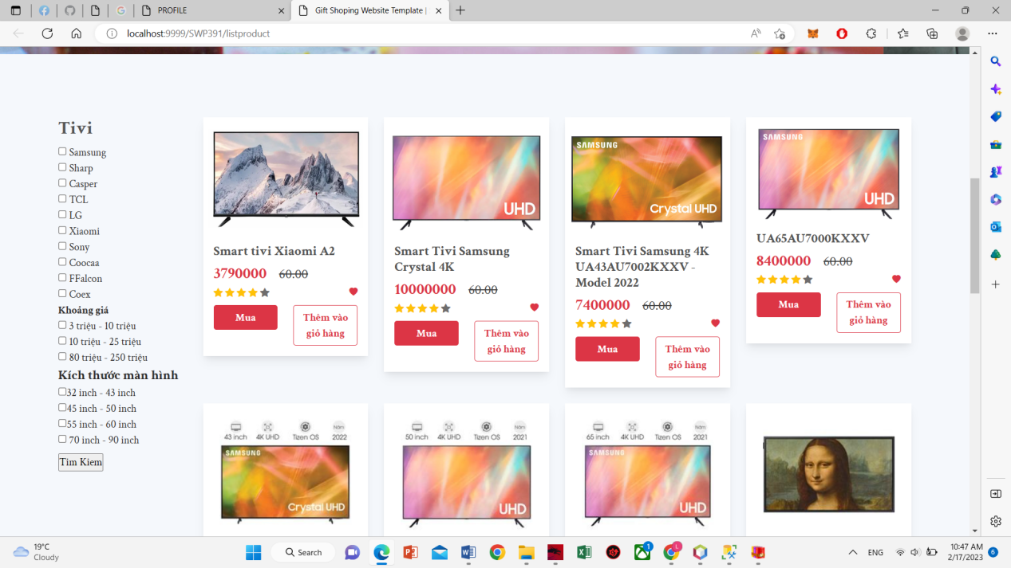

When users are on the home page, they can see the newest TV products. They can search and select to view the details of each product and then add it to the cart.

## TV detail

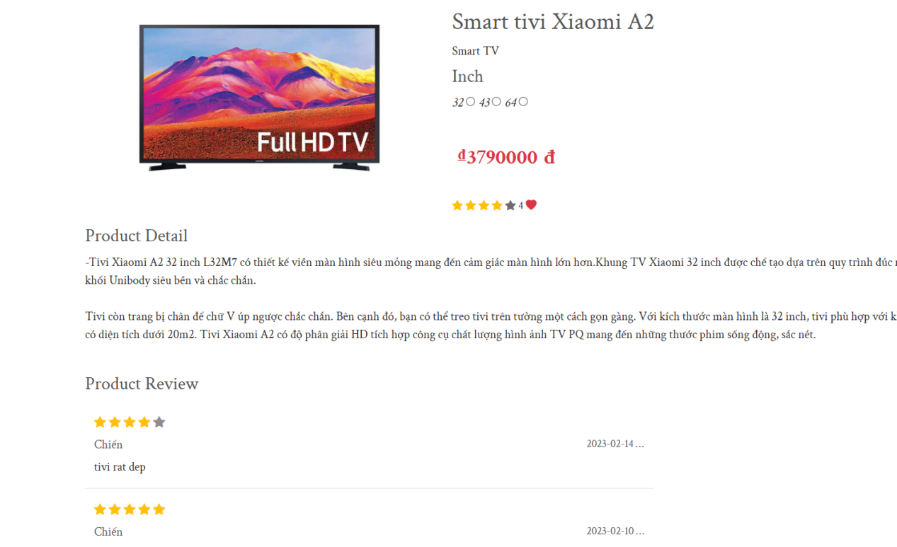

When the user selects each product on the home screen or search, it will go directly to the product detail page. This page allows users to view detailed product information such as color, resolution, insurance, etc.

## User profile

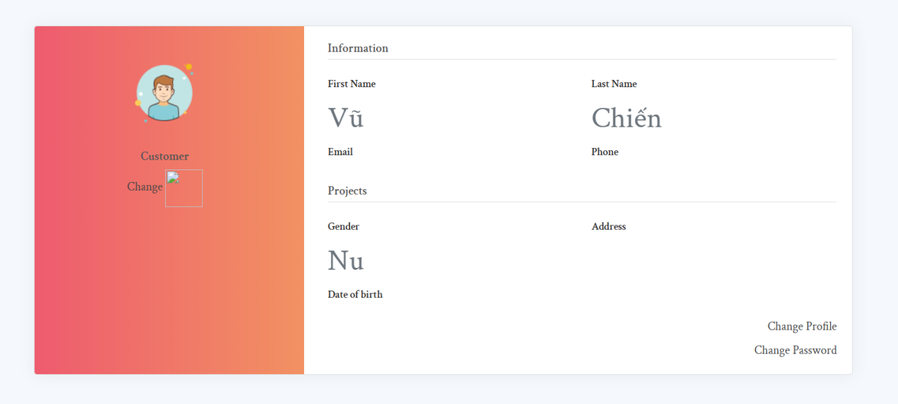

Users can view their profile by clicking in the avatar on the top right of the website. They can update their profile like: name, date of birth, gender,... They can also change their password here.

## Change Password

## 

A screen allow user to change password of his/her own password.

1. **Forgot Password** 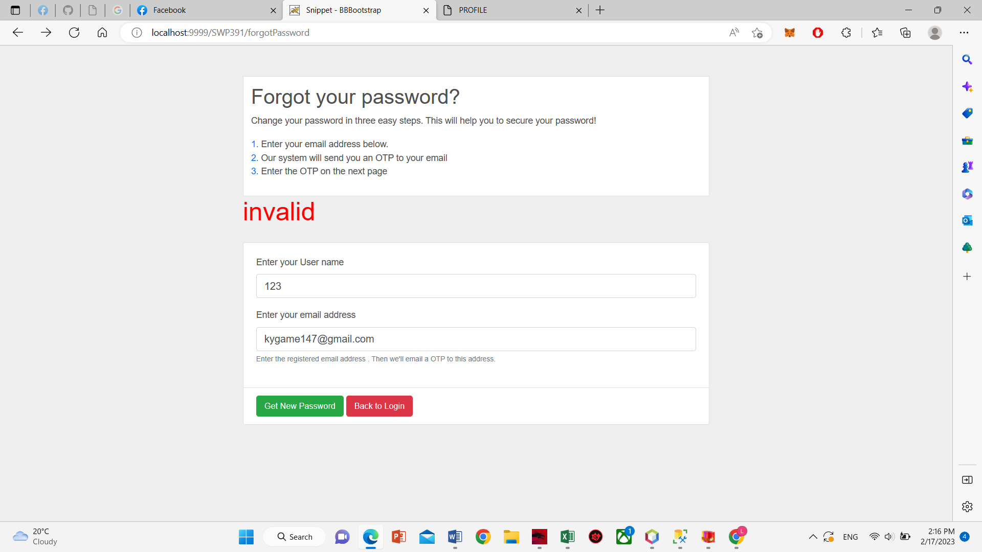

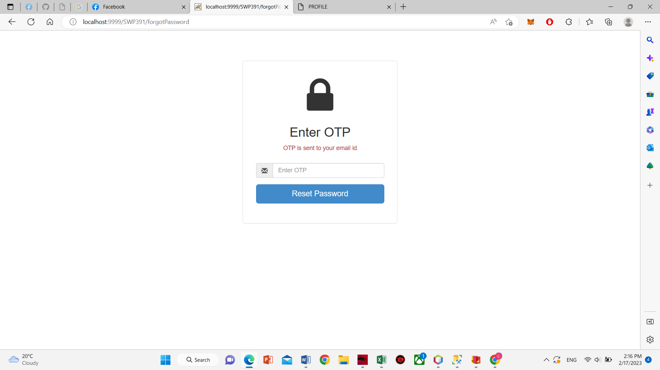

A screen when user input username and Gmail will send OTP to user gmail to change new pass word.

1. **Reset Password**

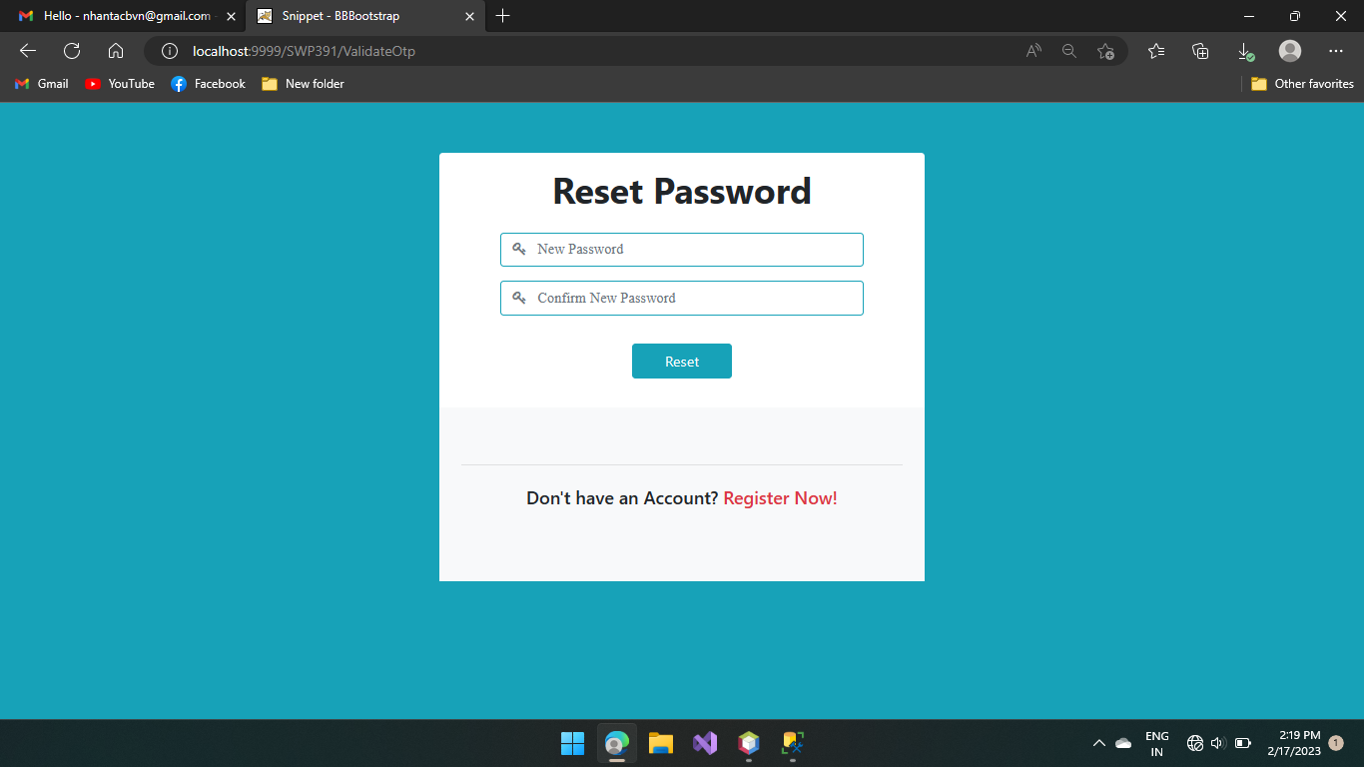

When user input corect OTP will direct to reset password to change user password.